1. 8-Puzzle Problem
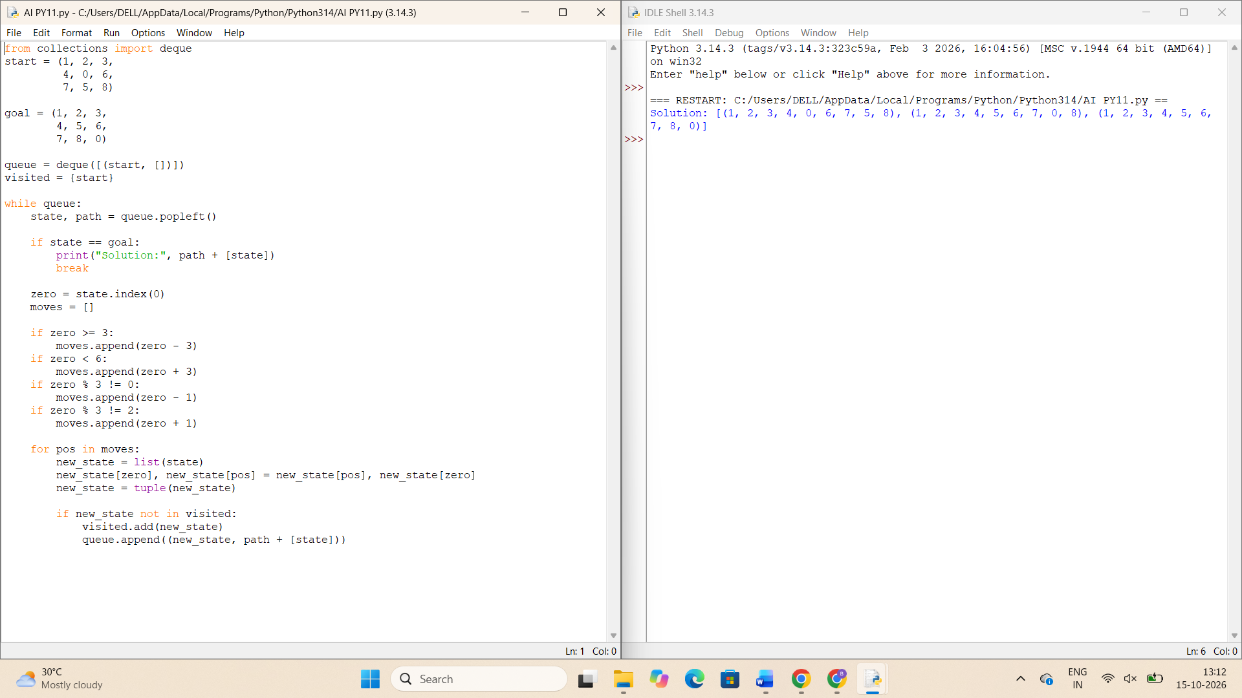
2. 8-Queen Problem
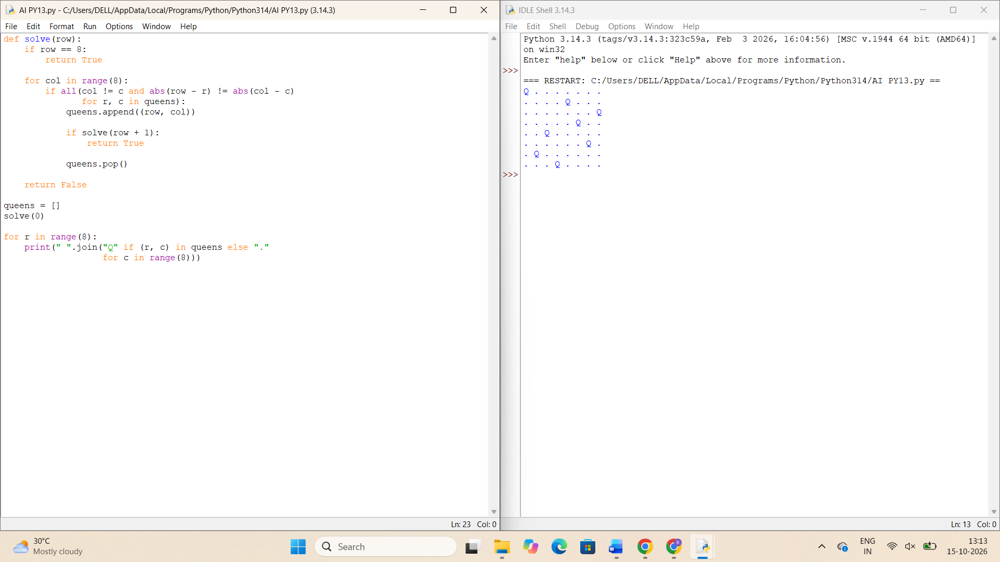
3. Water Jug Problem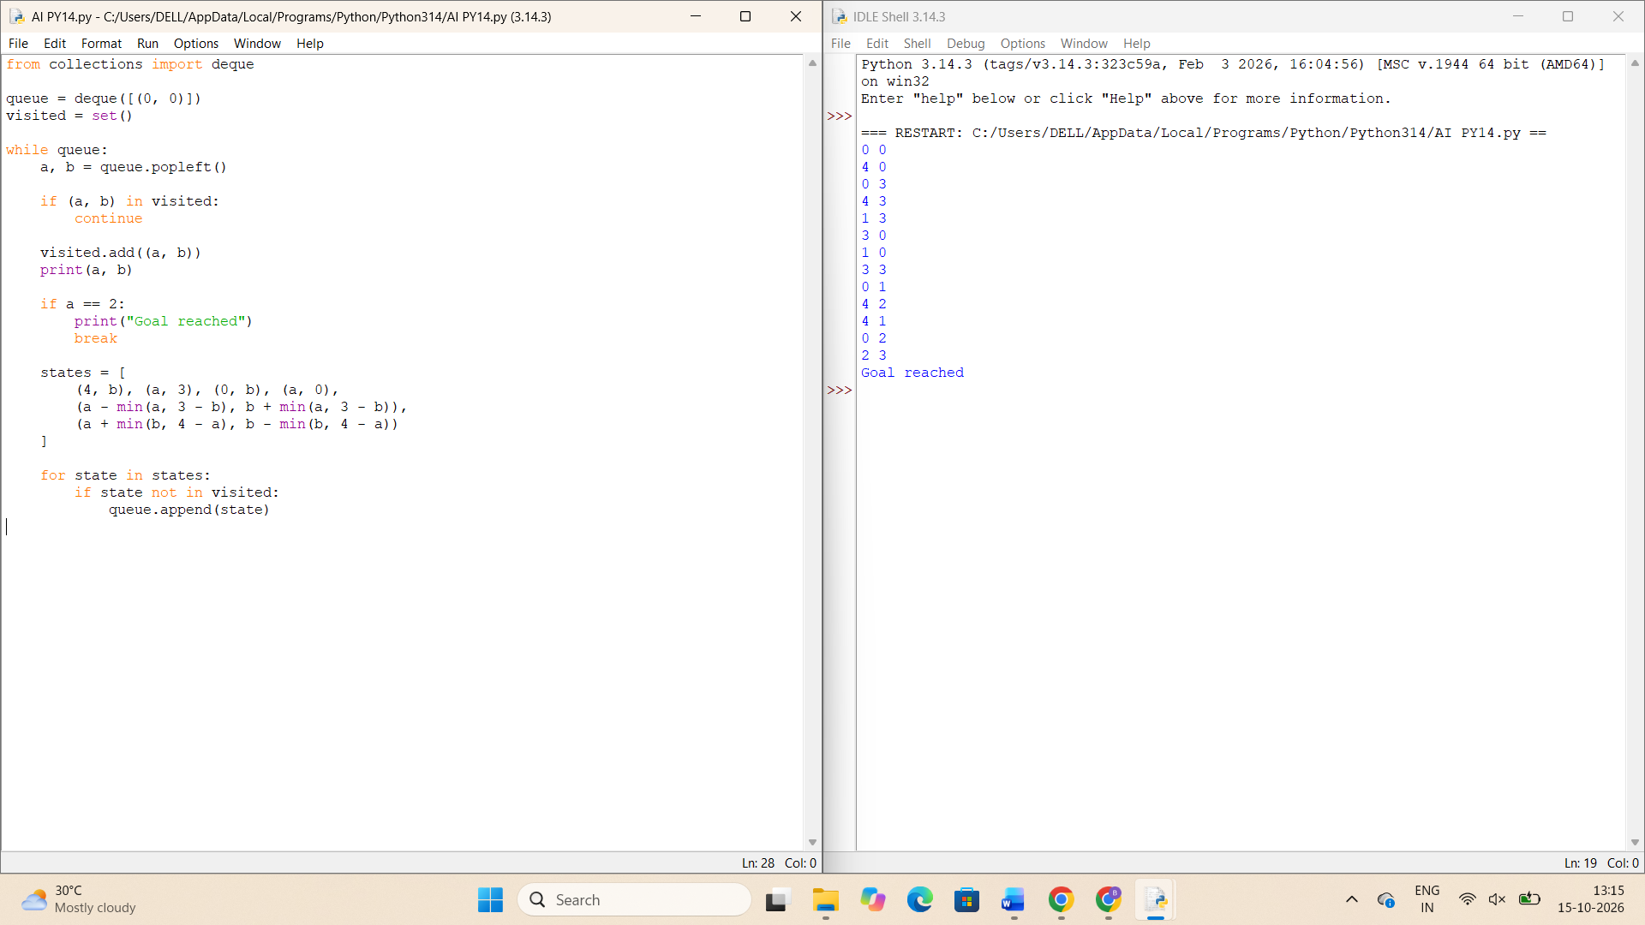
4. Crypt-Arithmetic Problem
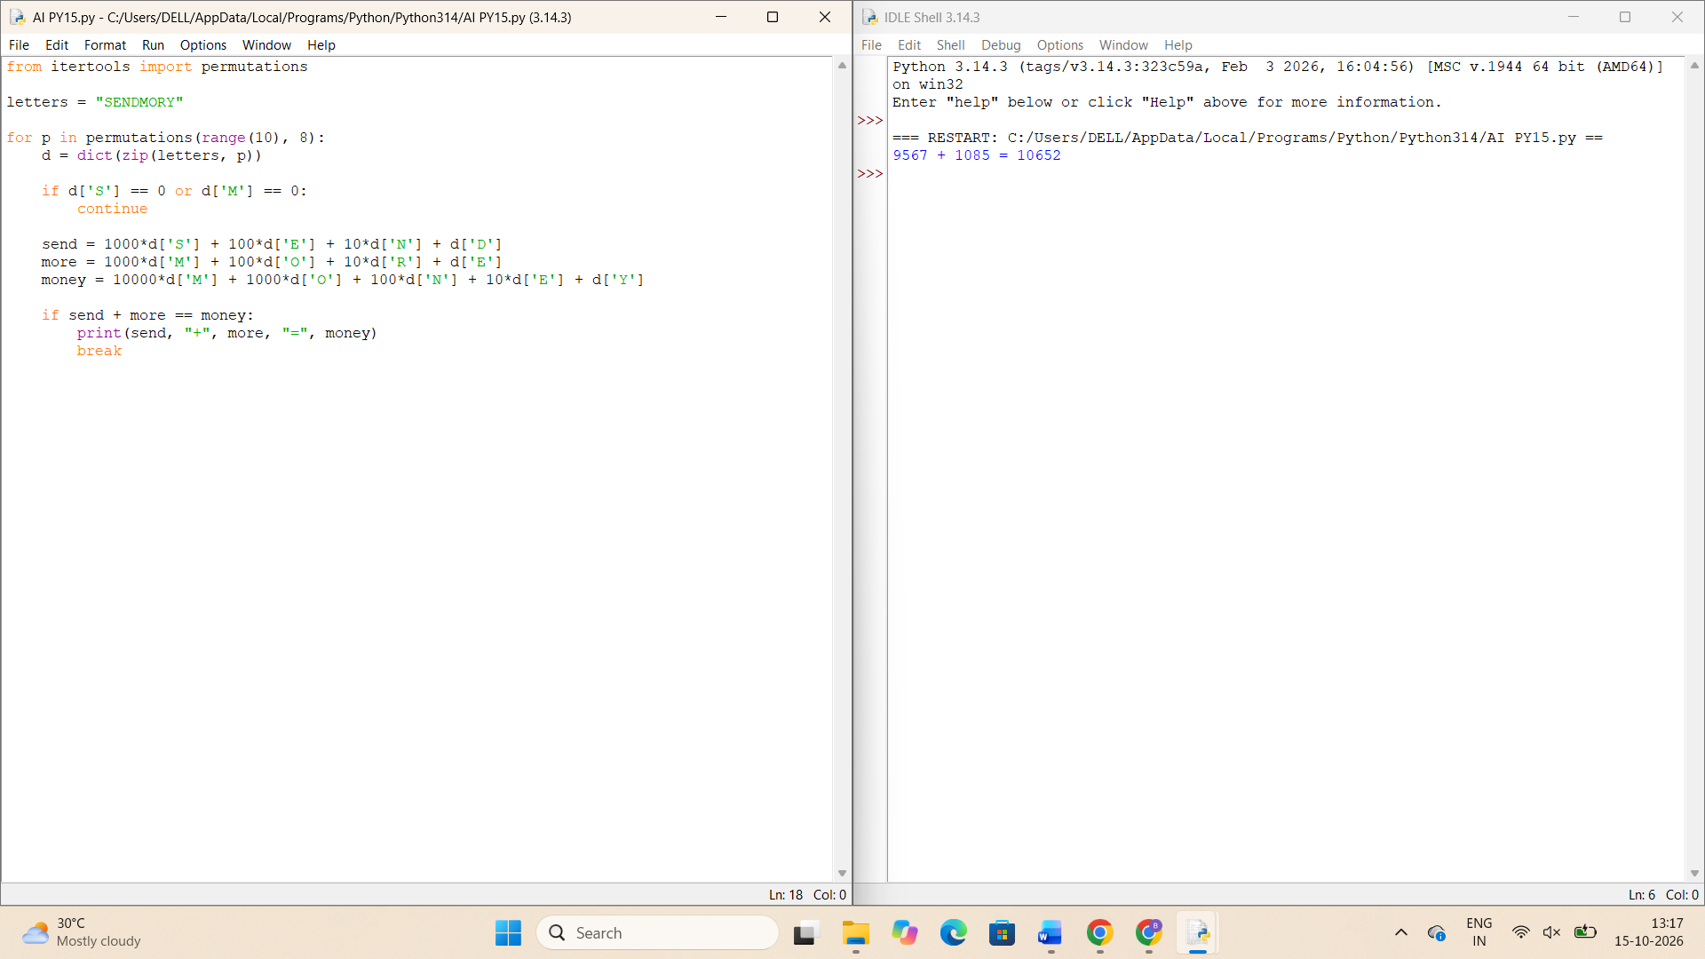
5. Missionaries and Cannibals Problem
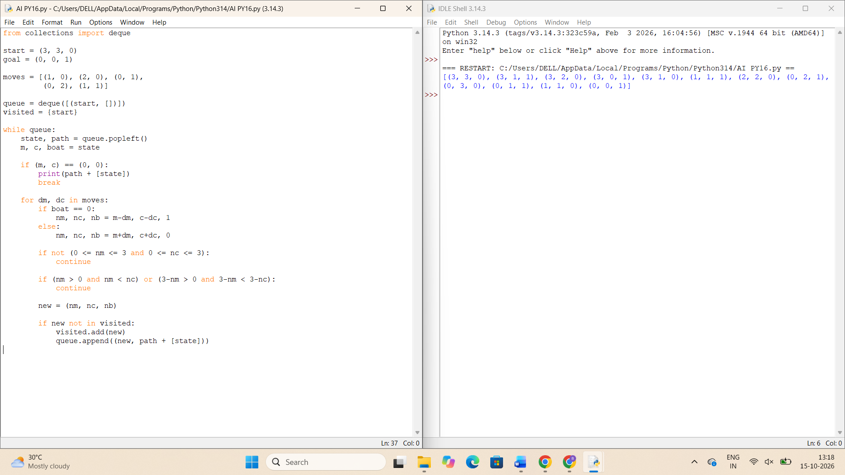
6. Vacuum Cleaner Problem
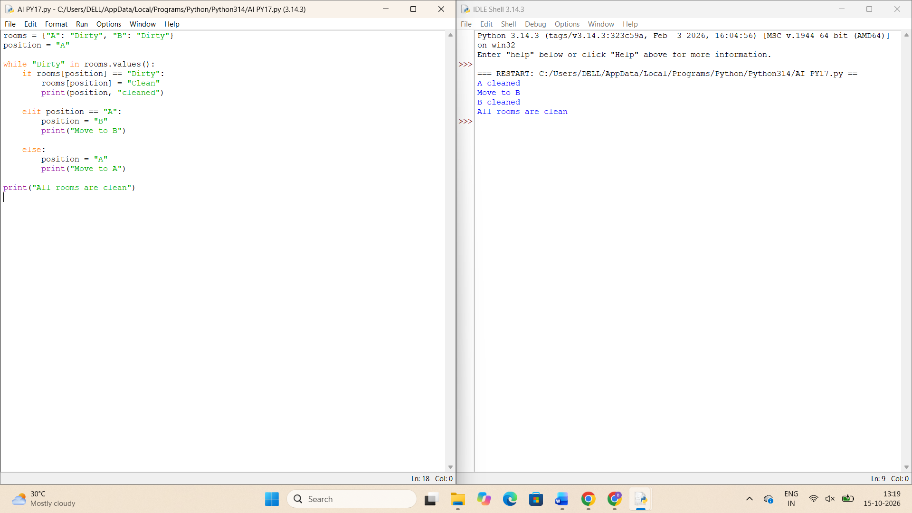
7. Breadth-First Search (BFS)
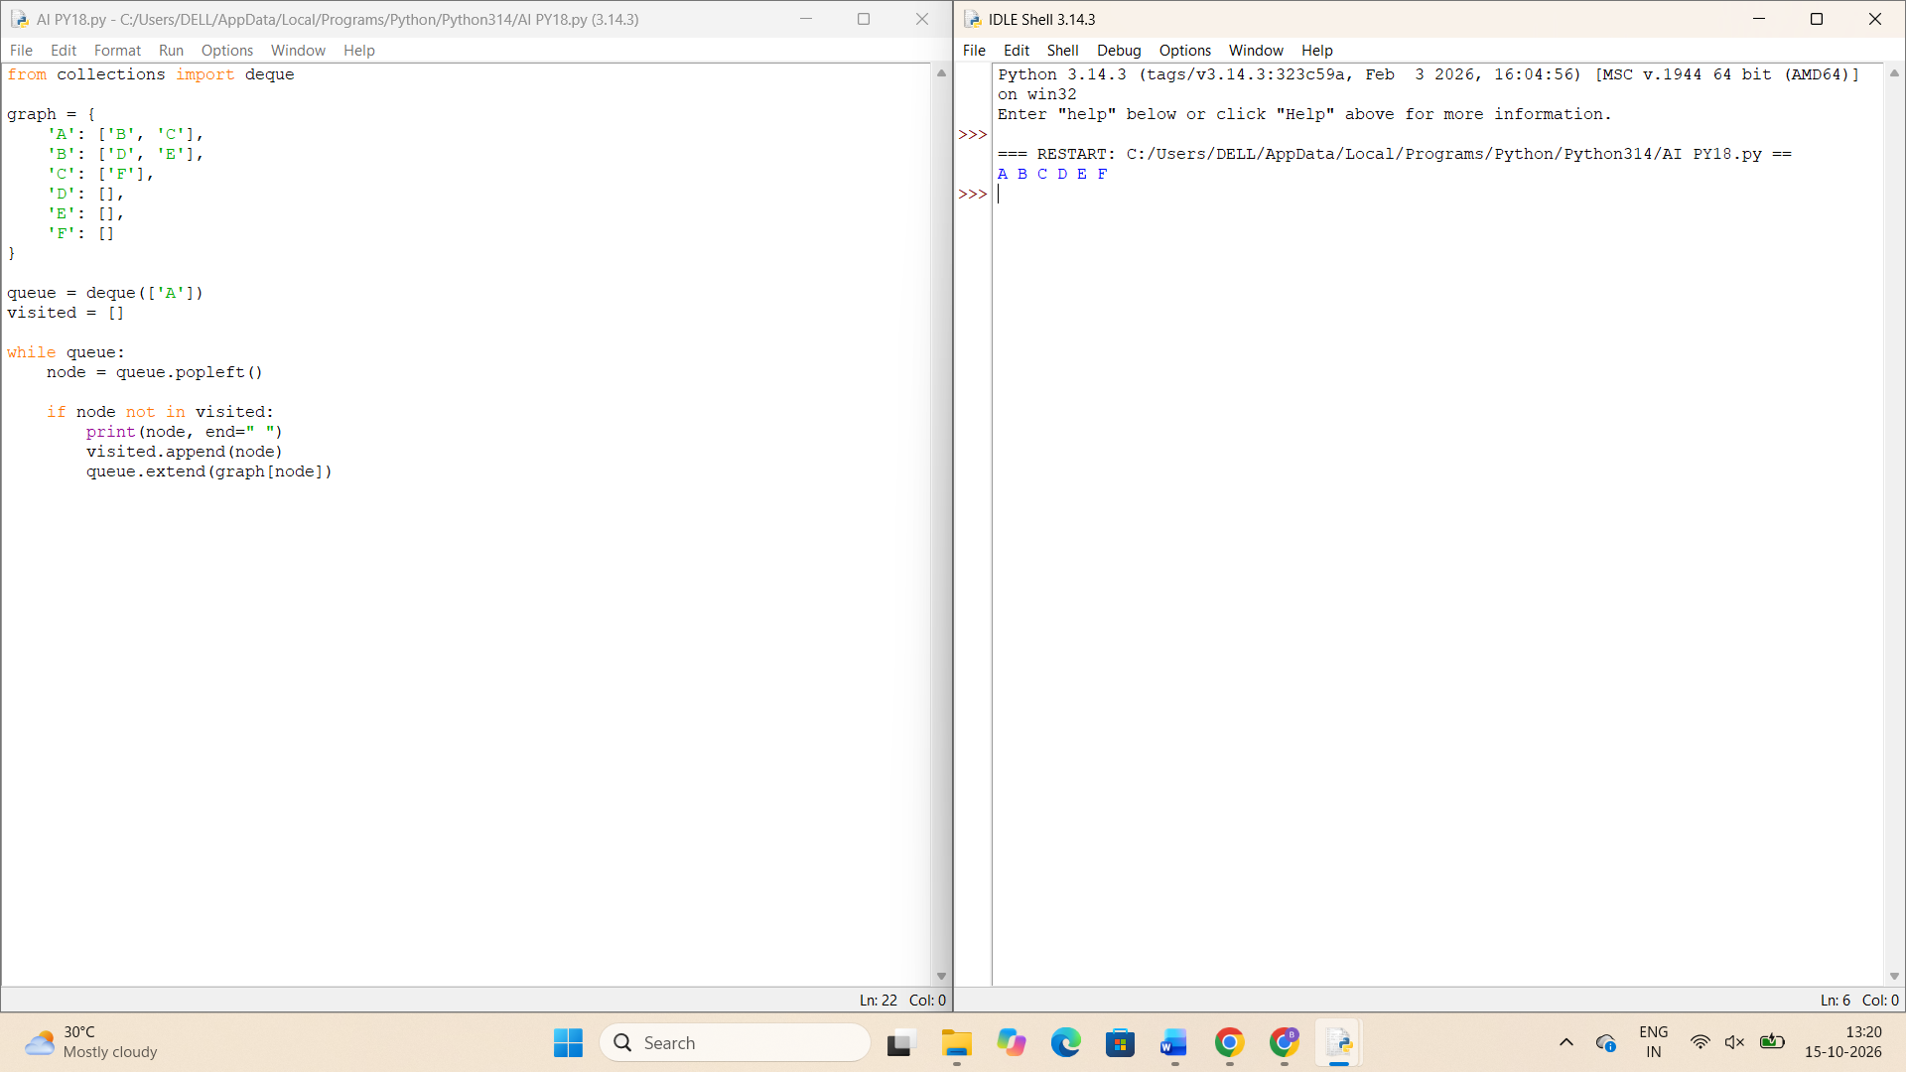
8. Depth-First Search (DFS)
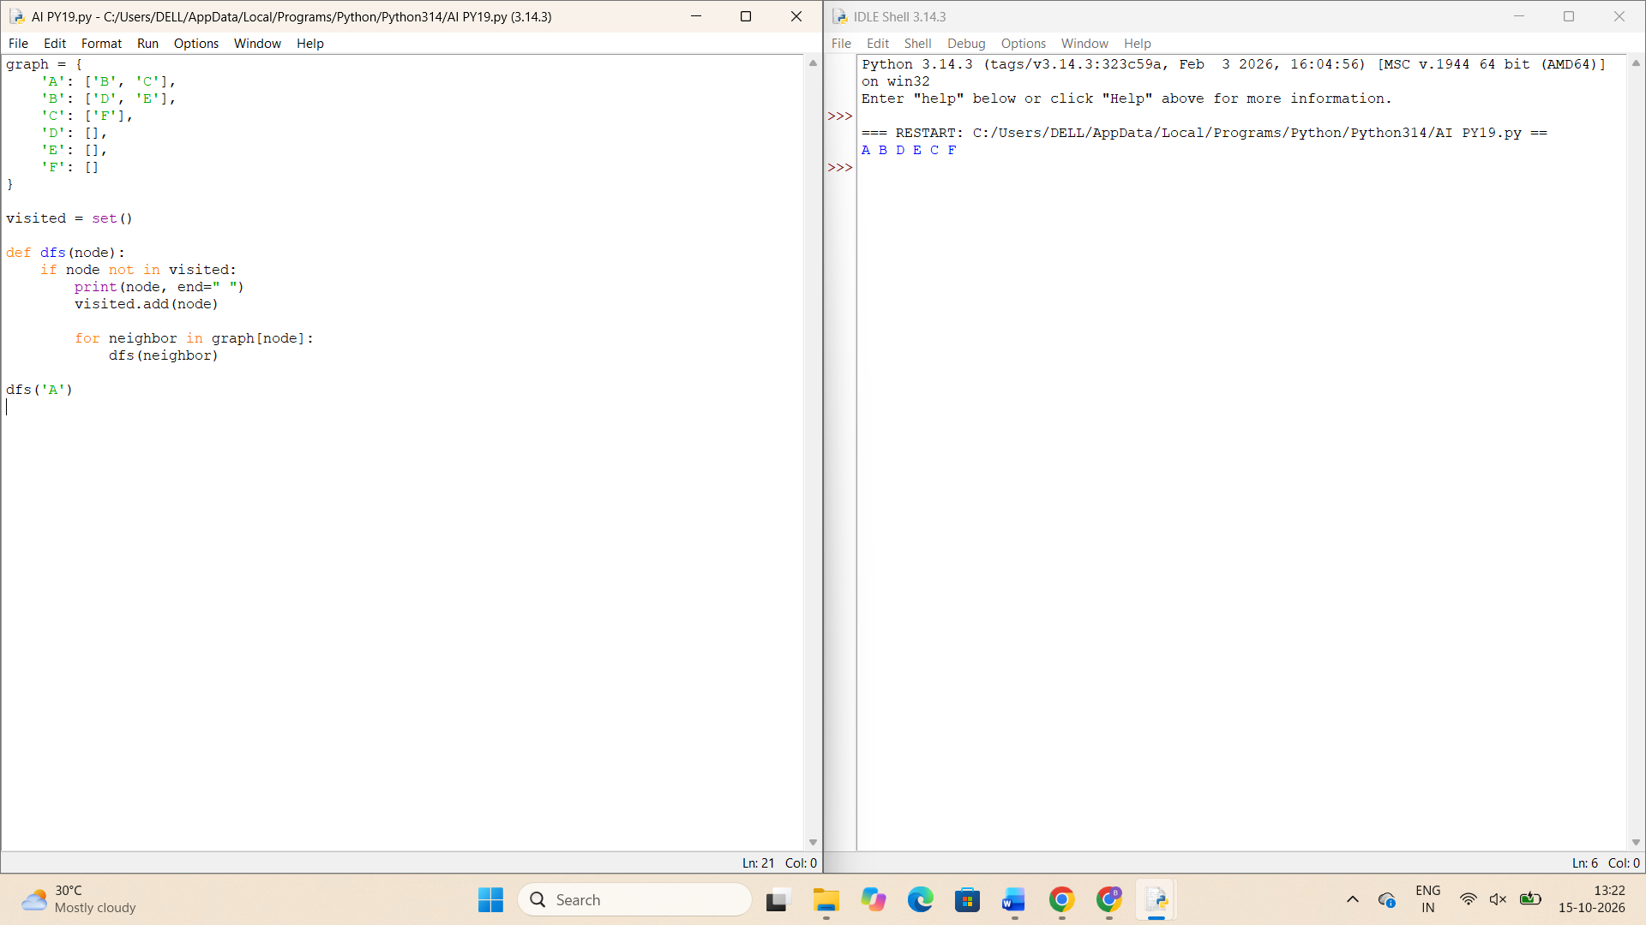
9. Travelling Salesman Problem (TSP)
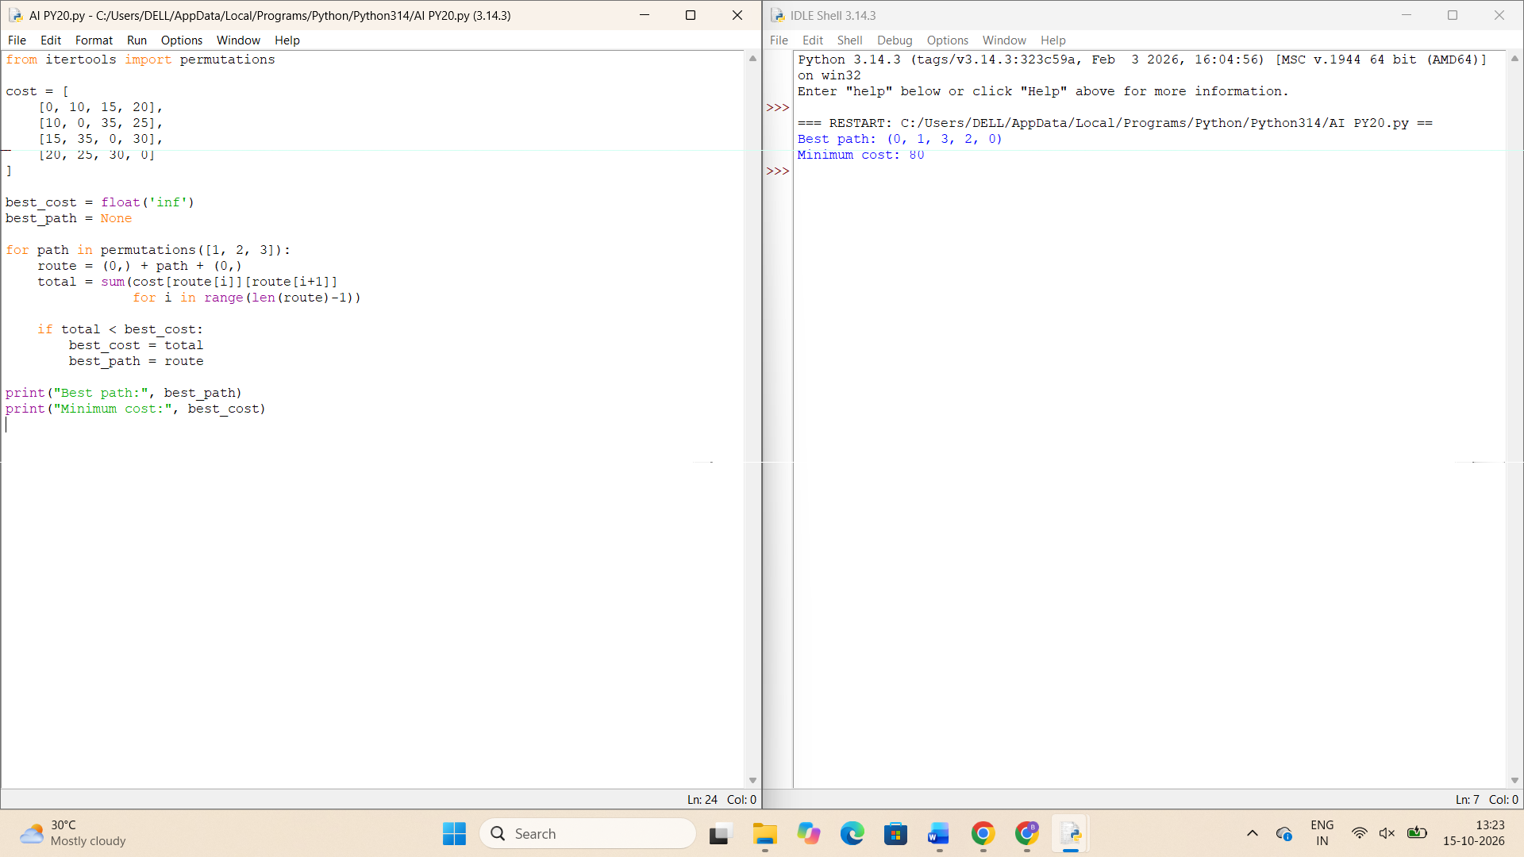
10. A* Search Algorithm


